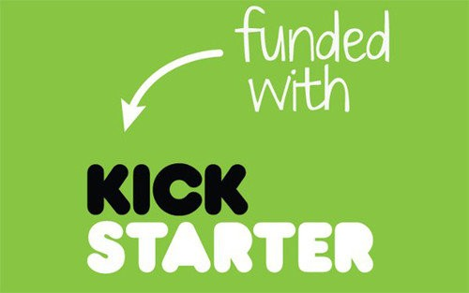

By Alexis Fox

Kickstarter is one of many crowdfunding platforms that allow people or companies go get the funding they need to get their projects off the ground. This report is the result of data analysis on a small sampling of the projects on Kickstarter and whether they’ve been successful or not.

Conclusions:

1. Most of the Kickstarter campaigns originate in the United States, even though the platform is available in many countries.
2. The more money the project requires, the less likely it is to succeed.
3. Theater projects had the most requests and the most success.

Limitations:

A major limitation to the conclusions in this sampling is the size of the sample. It appears that we only have data from approximately 1% of the actual projects started on Kickstarter, which means that the conclusions derived from this sampling may be skewed.

Other Tables or Graphs:

1. Which sub-categories had 100% failure rate.
2. Percentages of success, failure or cancellation based on goal amount range and category or sub-category.